RED RIBBON WEEK
“LIFE IS A PUZZLE, SOLVE IT DRUG FREE!”

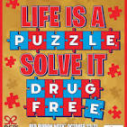
MONDAY | TUESDAY | WEDNESDAY | THURSDAY | FRIDAY
October 27th | October 28th | October 29th | October 30th | October 31st
RED Day!  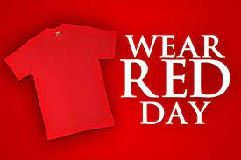  Wear Red to show that you are saying “NO” to drugs! | Use your head. Don’t do drugs!  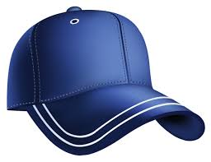  Wear your favorite hat! | Your future is bright!  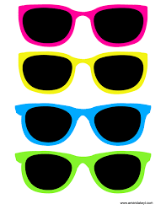  Wear neon colors or sunglasses! | “Sock-it” to drugs!  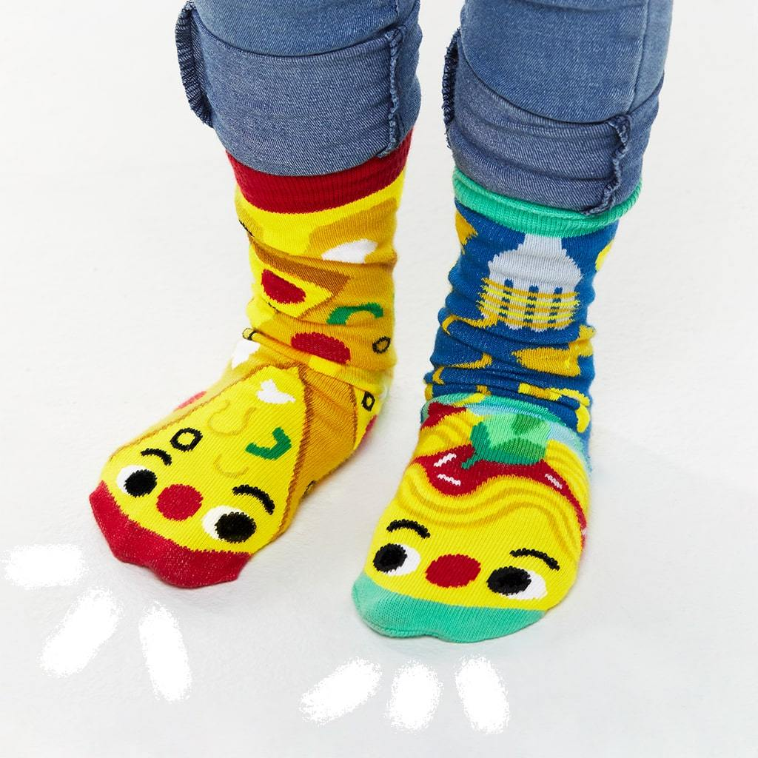  Wear your craziest, most mismatched socks! | Good characters make good choices!  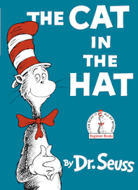  Dress as your  favorite book  character!

